**Stage 2 Physics Motion Test 2 – 2014 Name: ________**

(60marks - 60 minutes)

**Question 1 (10 marks)**

A 23.5 g bullet is fired into a 1.20 kg block of soft clay, which is initially at rest as shown below. After impact, the bullet imbeds in the clay block and they move for 2.2 m before coming to rest. The initial speed of the bullet was 145 ms-1.

* 1. Find the initial speed of the bullet and block immediately after impact. [3]
  2. Was the collision between the bullet and block elastic? Use calculations to support your answer. [3]
  3. Find the average force of friction between the block and the table as it came to rest. [2]
  4. Discuss the energy transformations involved in the above interaction. [2]

**Question 2 (8 marks)**

The Space Shuttle “Endeavour” has a mass of 5000 kg and was travelling to the Moon at a speed of 3540 kmh-1, when an explosion ripped the ship into two pieces of mass 1250 kg and 3750 kg respectively.

After the explosion, the smaller front section of the shuttle was moving in its original direction at twice the original speed.

1. Find the velocity of the rear section after the explosion. [4]
2. What impulse was experienced by the front section of the shuttle? [2]
3. Which section of the shuttle experienced the greatest force during the explosion? Explain. [2]

**Question 3 (6 marks)**

During a futuristic “shoot out” in space, James is firing bullets at his adversaries. Note: he is not attached to anything to prevent him drifting in space.

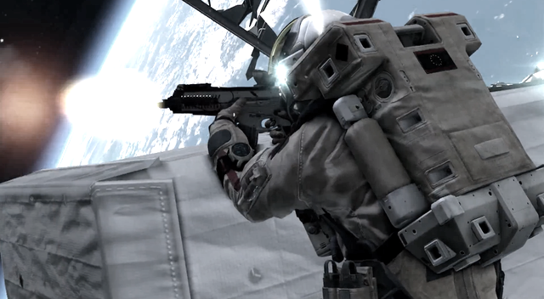*Estimate* his recoil velocity after firing a burst of 50 bullets. Be sure to list all of your assumptions.

**Question 4 (15 marks)**

A large metal ball of mass 425 kg is used to demolish a wall. It is allowed to swing through a vertical drop of h (m) as shown in the diagram below. The graph below shows how the speed of the ball varies with time from the moment it is released.

h (m)

1. Air resistance retarded the ball’s motion. How is this evident from the graph? [1]
2. Find the Kinetic Energy of the ball after 1.2 seconds. [2]
3. What would the Kinetic Energy of the ball have been if air resistance wasn’t present and it only took 1.1 s to reach the wall? (hint: extrapolate from the graph) [3]
4. Find “h”, the vertical height through which the ball fell. [2]
5. How much work was done on the ball by the wall during the 0.2 s of impact? [1]
6. What was the average force exerted on the ball by the wall? [4]
7. After the collision with the wall, the ball’s momentum was reduced to zero. Does this contravene the “Law of Conservation of Momentum”? Explain. [2]

**Question 6 (7 marks)**

The diagram below shows Carina Vogt at various stages of her medal winning jump at the recent Sochi Winter Olympics. At position A, she has negligible speed. Carina and her equipment have a combined mass of 68 kg. Ignore friction for this question.

1. 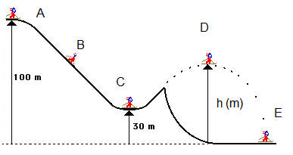Find Carina’s speed at position C. [3]
2. At position D, she has a horizontal velocity of 28.0 ms-1 and is at the maximum height of her jump. What is the height (h) of her jump? [4]

**Question 7 (3 marks)**

Each day, when Victoria gets home from work, she climbs the stairs to her second-floor apartment. On some days she walks up the stairs and on other days she runs up them.

Victoria’s potential energy, kinetic energy and power output may change as she climbs the stairs.

Assuming that Victoria’s mass remains constant, and that she is halfway up the stairs:

* 1. Her potential energy is (circle the correct response)

*Greater the same less* for runningcompared to walking.

her kinetic energy is (circle the correct response)  
  
*Greater the same less* for runningcompared to walking.

* 1. her power output is (circle the correct response)

*Greater the same less* for runningcompared to walking.

**Question 8 (3 marks)**

The electric hoists like the one below are used by mechanics to inspect underneath cars. One such hoist has a power rating of 850 W. How long would it take to lift the 2.3 tonne 4x4 shown to a height of 2.0 m?



**Question 9 (8 marks)**

Hamish is pulling his little sister along level ground at a *constant speed of 1.5 ms-1* as shown in the diagram below. He pulls her in the trolley for 30.0 m.

1. 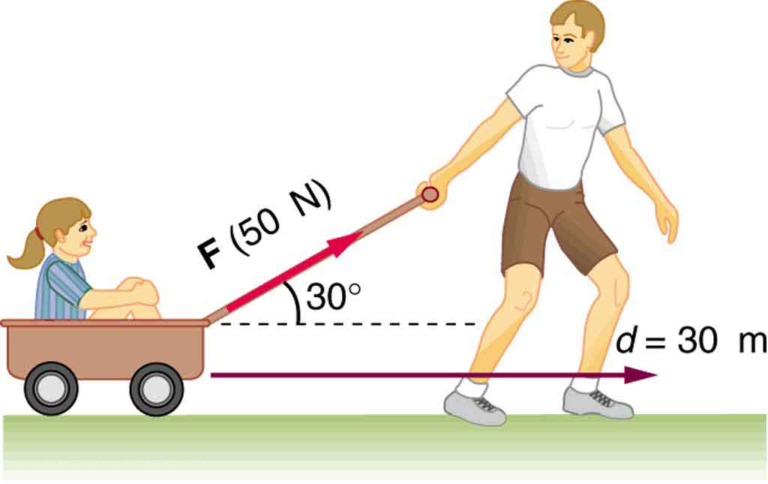Find the force of friction opposing the trolley’s motion? [2]
2. What work has Hamish done on the trolley while pulling it along the ground. [2]
3. What average power is Hamish providing while pulling the trolley? [2]
4. Is 30o to the horizontal the best angle for Hamish to pull the handle of the trolley? Explain your answer carefully. [2]

**END OF TEST ☺**